Assignment 7

Name – Abhishek Agrahari

Roll Number 190123066

Question 1

Formula Used-

${\hat{I}}_{M}$ = ${\hat{μ}}_{anti}$ = $\frac{2}{M}\sum_{i=1}^{M/2}{{\hat{Y}}_{i}}$, where ${\hat{Y}}_{i}=(ⅇ^{\sqrt{U_{i}}}+ⅇ^{\sqrt{{1-U}_{i}}})/2$

$s_{anti}^{2}=\frac{1}{n-1}\sum_{i=1}^{n}{{\left({\hat{Y}}_{i}-{\hat{μ}}_{anti}\right)}^{2}}$ where n = M/2.

95% confidence interval = ( ${\hat{μ}}_{anti}-1.96\frac{s_{anti}}{\sqrt{n}}$, ${\hat{μ}}_{anti}+1.96\frac{s_{anti}}{\sqrt{n}}$) where n = M/2 and santi as defined above.

For different values of M, IM and 95% confidence interval obtained from the generated sample are as below –

i) M = 100

IM = 1.9835514858163157

95% confidence interval =

(1.9680162496788438, 1.9990867219537876)

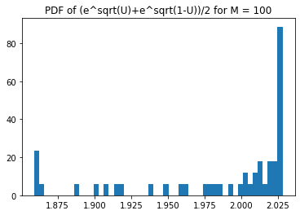

ii) M = 1000

IM = 1.9970388257694407

95% confidence interval =

(1.993776847093539, 2.0003008044453425)

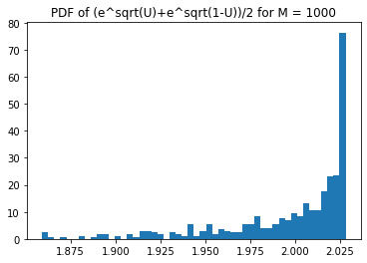

iii) M = 10000

IM = 1.9993787032361658,

95% confidence interval =

(1.998451217156572, 2.0003061893157597)

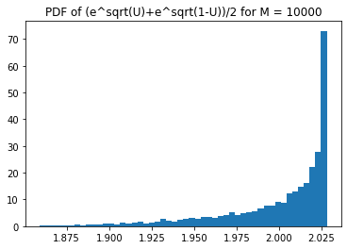

iv) M = 100000

IM = 1.9997835287779493,

95% confidence interval =

(1.9994935248575483, 2.0000735326983503)

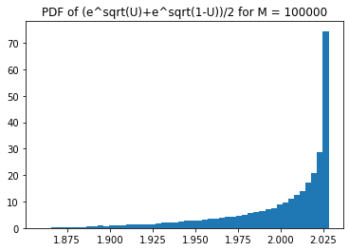

Question 2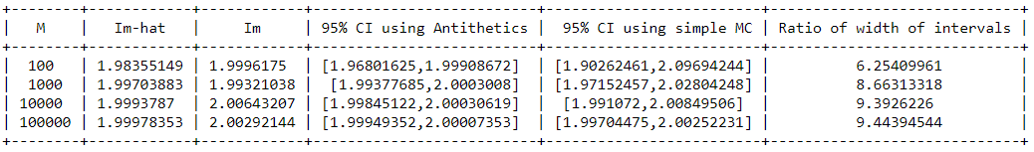

Ratio of width of interval = $\frac{ Width of 95\% CI using simple monte carlo}{Width of 95\% CI using antithetic method}$

Actual value of I = $\int_{0}^{1}{ⅇ^{\sqrt{x}}ⅆx}=2$

As value of M increases, ${\hat{I}}_{M}$ and $I_{M}$ both gets closer to actual value of I.

For same value of M, ${\hat{I}}_{M}$ is closer to I than $I_{M}$ for all M except for M = 100. For M = 100, it is just luck due to small sample space.

Width of confidence intervals in antithetic method are smaller as compared to simple monte carlo and this ratio increases with increase in M.